LAB 2
INSTALL DVWA ON WINDOWS
- Introduction:
DVWA - Damn vulnerable web application is a PHP / MYSQL source code application that integrates security logic and web applications in PHP source code. Logical programming errors may apply to programming languages ​​to minimize the possibility of generating vulnerabilities from programmatic thinking. The main goal of DVWA is to create a legitimate hacking / pentest practice environment. Help web application developers understand more about secure and secure programming. In addition, DVWA also provides students with learning methods and practices that exploit web application security vulnerabilities at basic and advanced levels.

- Preparation:

- Computer running windows operating system. Require to disable the firewall on the system.
- The source code management mysql - phpmyadmin
https://www.phpmyadmin.net/downloads/
- XAMPP download by following link:
https://downloadsapachefriends.global.ssl.fastly.net/xampp-files/5.6.31/xampp-win32-5.6.31-0-VC11-installer.exe?from_af=true
- DVWA download the following link:
http://www.dvwa.co.uk/
- The browser software chrome, firefox 10.0, 7zip, Notepadd ++.

3. Implementation steps
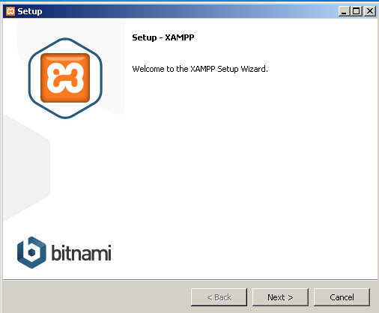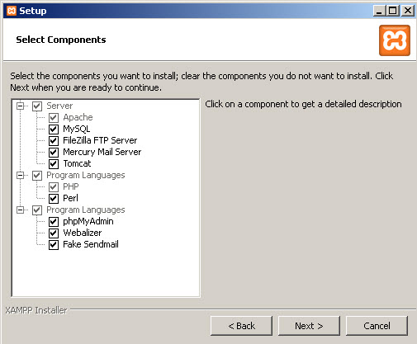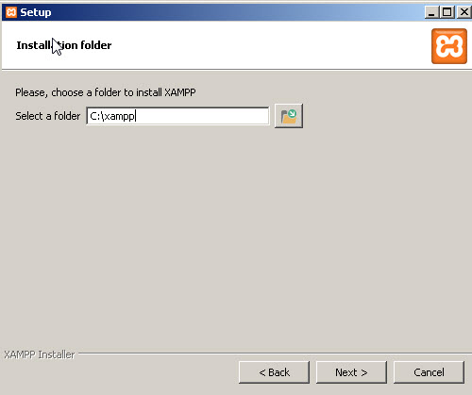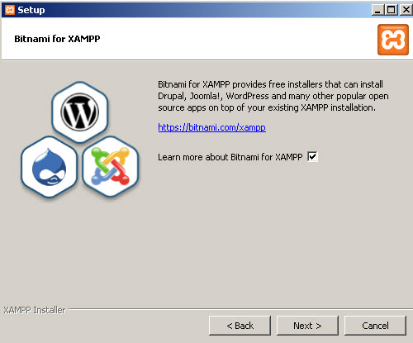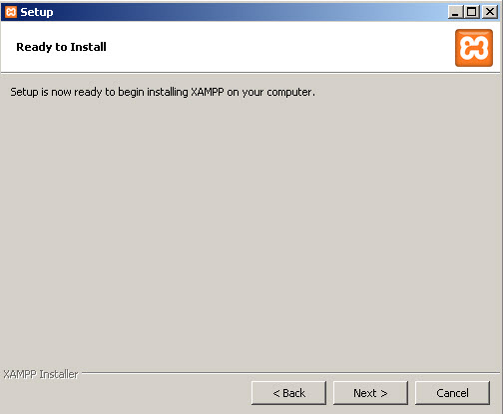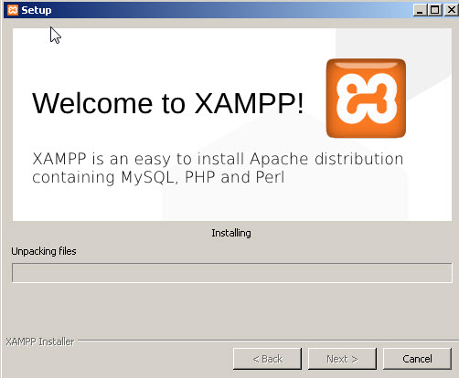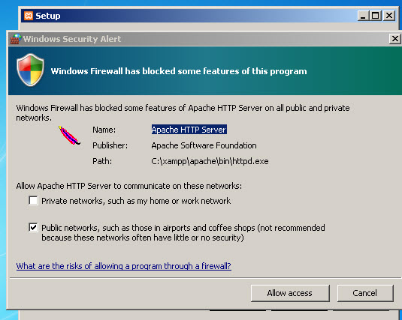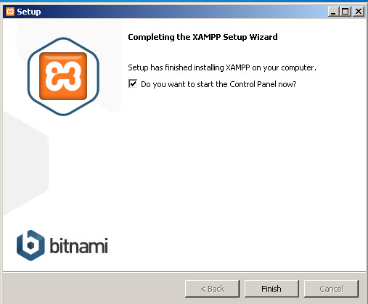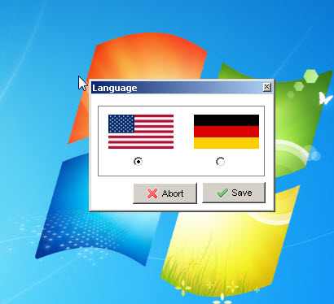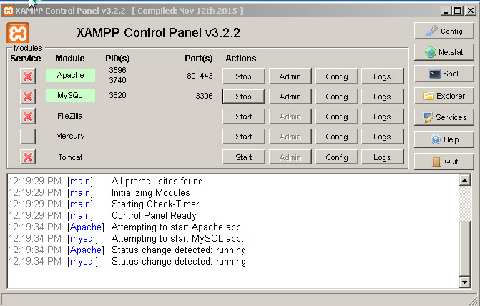

Install DVWA: Copy the source code downloaded from the link above to the folder C: \ xammpp \ htdocs
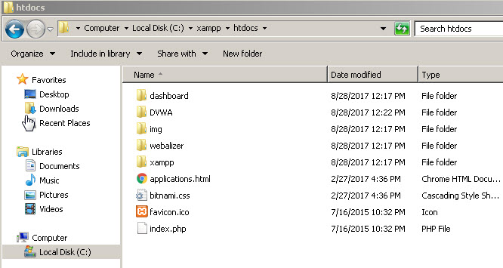
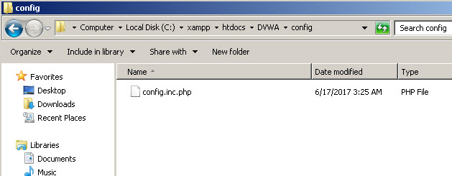

Copy the phpmyadmin directory into C: \ xampp \ htdocs
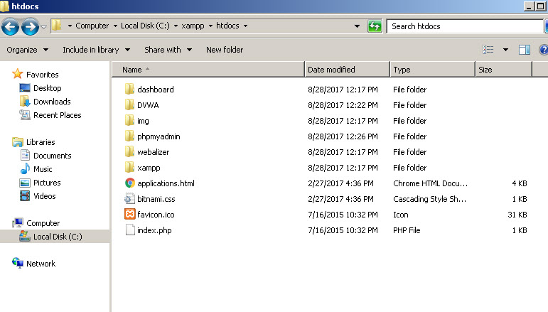
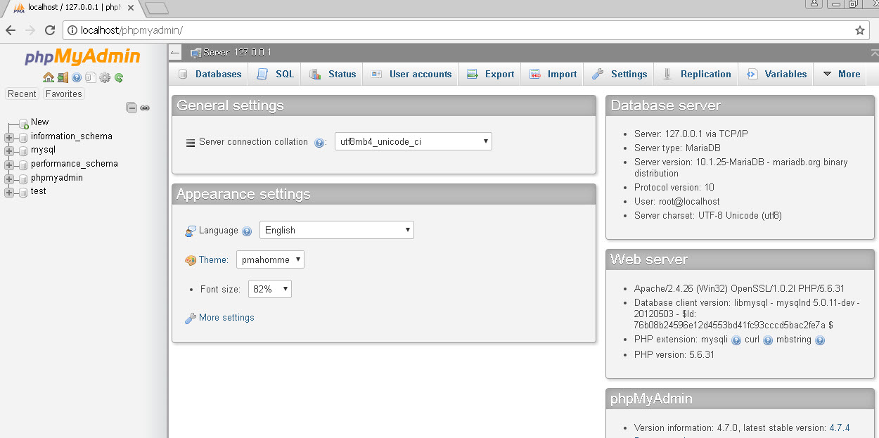

Create database: dvwa
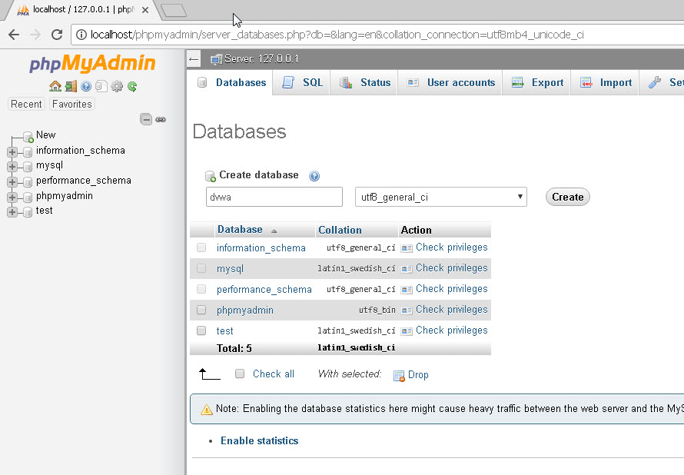

Create user to connect database dvwa:
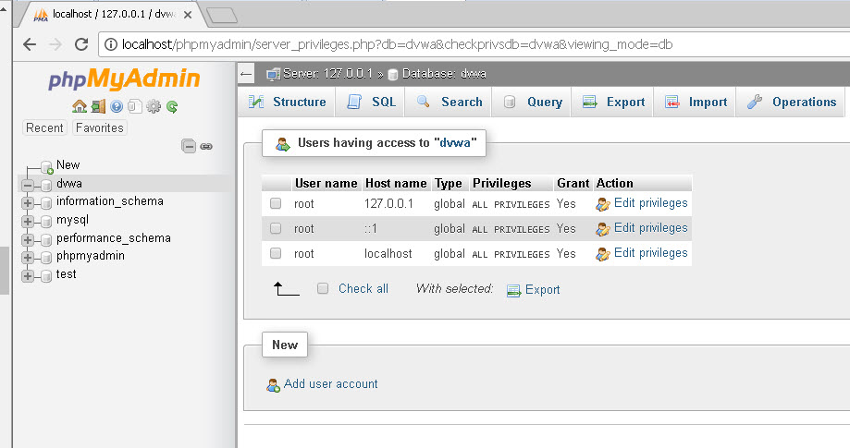
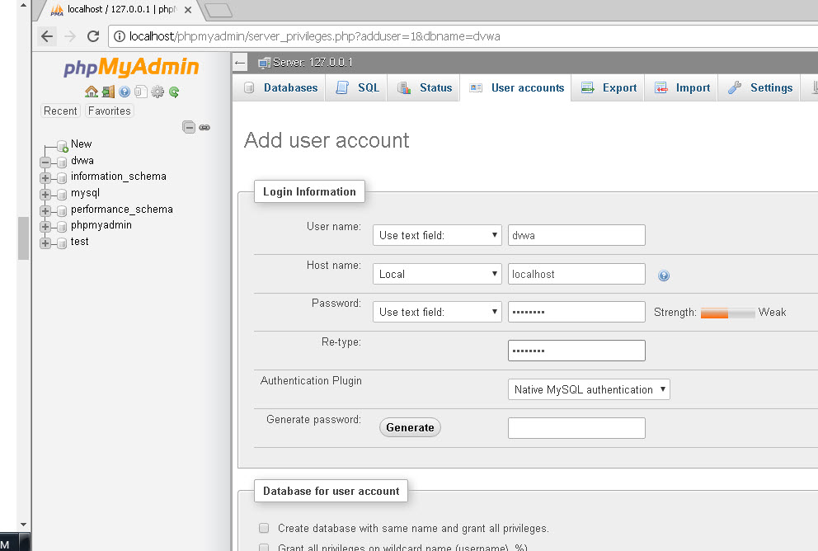

Edit the dvwa configuration file with the database and user information connected:
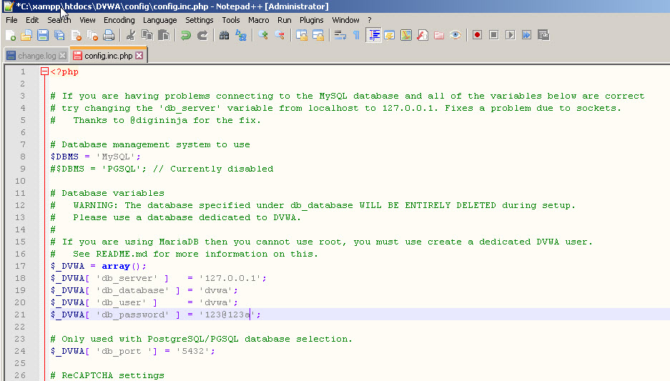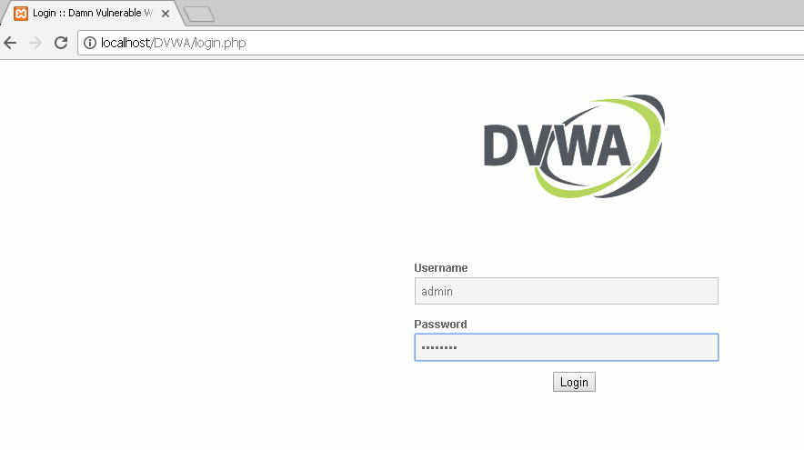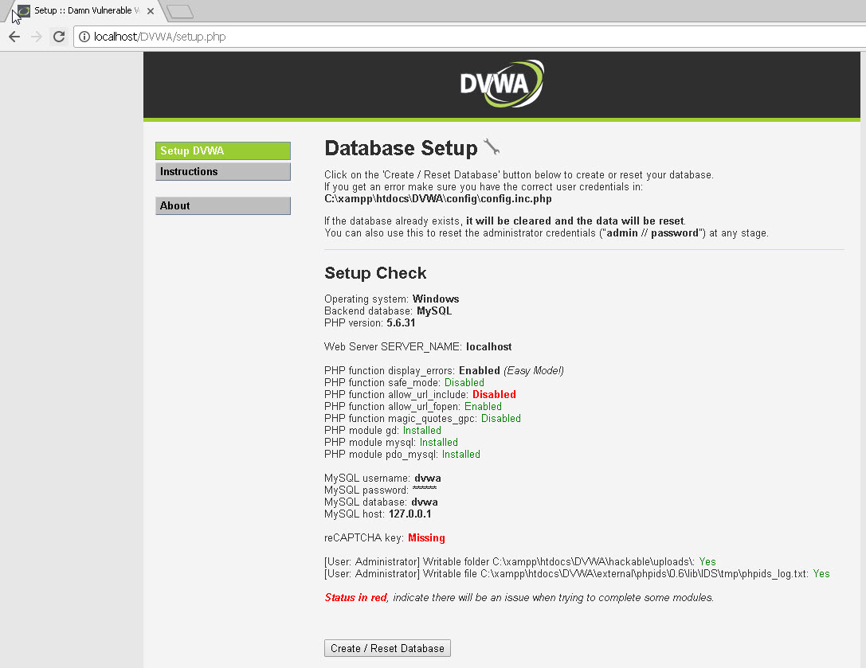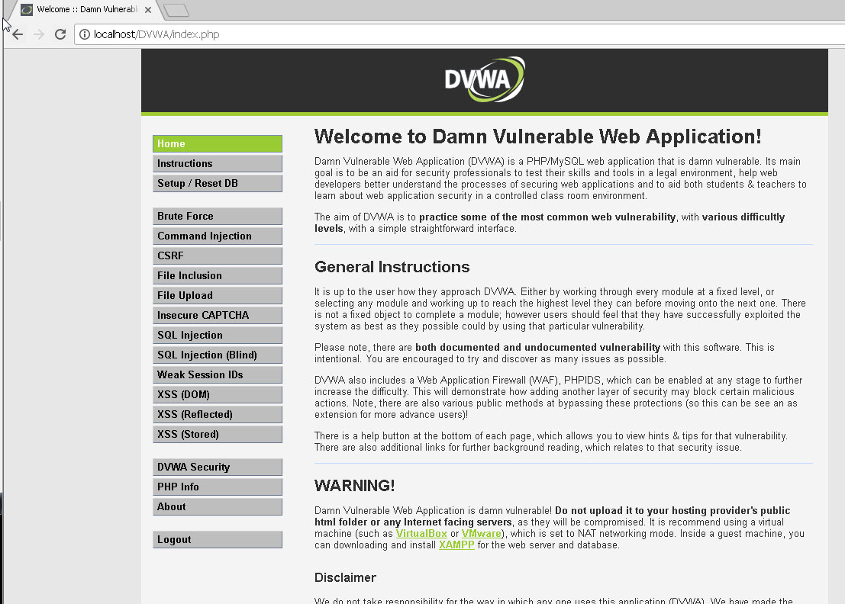

3.References:
- http://www.effecthacking.com/2015/12/setup-dvwa-using-xampp-windows.html
- https://graftene.co.uk/blog/dvwa-lesson-installing-on-windows/

